CA-6: As a clinic staff, I want to record a patient's consultation, so that I can properly document the patient's diagnosis, treatment plan, and prescribed medicines for accurate patient records and inventory management.

Rationale
This documentation focuses on the design and development of the login feature of the clinic desktop application for the Clinic Staffs. It aims to provide a secure and reliable authentication mechanism for clinic staff accessing the desktop application. This can be achieved by validating the user credentials then route the user to the appropriate section of the application such as dashboard. To be more user friendly, feedback can be given to users during failed attempts or validation errors.

Scope of Work
- Authentication: Verifying the credentials (username and password) of existing users against a secure database.
- Input Validation: Providing client-side checks for missing information (blank username or password fields) before processing the login request.
- Feedback Mechanism: Displaying specific, actionable error messages for incorrect credentials or missing inputs based on the defined acceptance criteria.
- Environment: The module is designed to operate within a Java SE environment utilizing a text-based user interface.

Business Value
- Data Security & Privacy Compliance: Ensures that sensitive patient medical records and clinic inventory are protected from unauthorized access.
- Accountability: By authenticating individual staff members, the system can audit and track actions (e.g., who updated an inventory item or accessed a record).
- Operational Efficiency: A smooth, clearly validated login experience minimizes friction for staff starting their shifts, getting them to their core tasks faster.

System Architecture
The desktop application (e.g., built using Java SE) will utilize a standard tiered architecture to separate the user interface from business logic and data access.
- Presentation Layer (UI): The desktop interface handling user inputs (username and password). It performs preliminary client-side validation to ensure fields are not empty before invoking backend services.
- Business Logic Layer (Authentication Service): Receives the login request. It is responsible for fetching user details from the database, hashing the provided password, and comparing it against the stored hash.
- Data Access Layer (DAO/Repository): Manages the connection and queries to the application's database.
- Database: Stores the registered user accounts, roles, and securely hashed passwords.
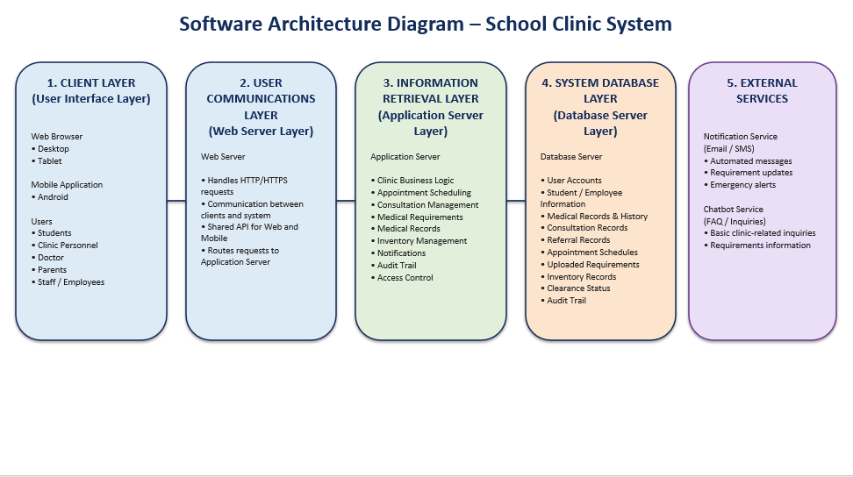

Data Models

Use Case Diagram
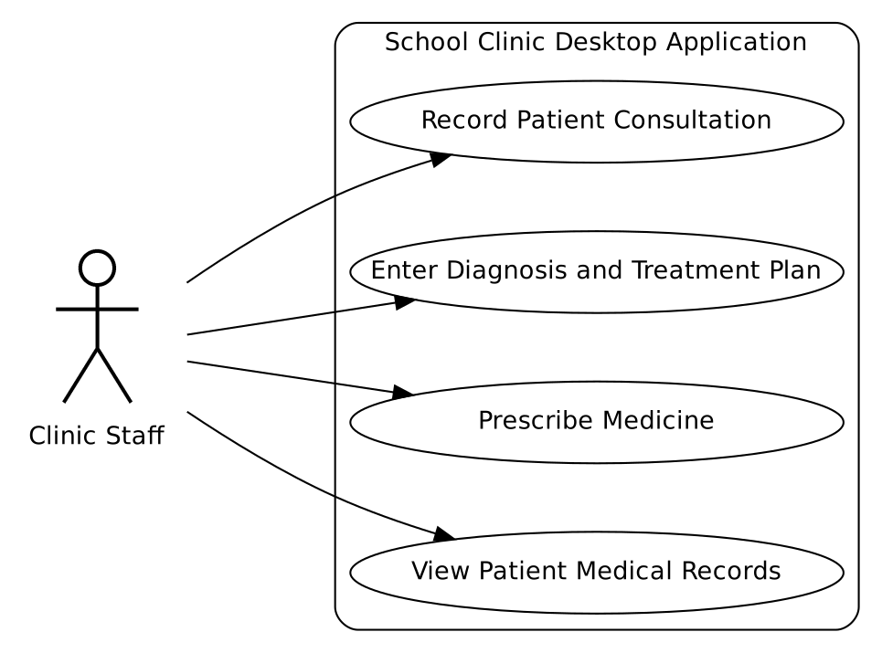

Activity Diagram
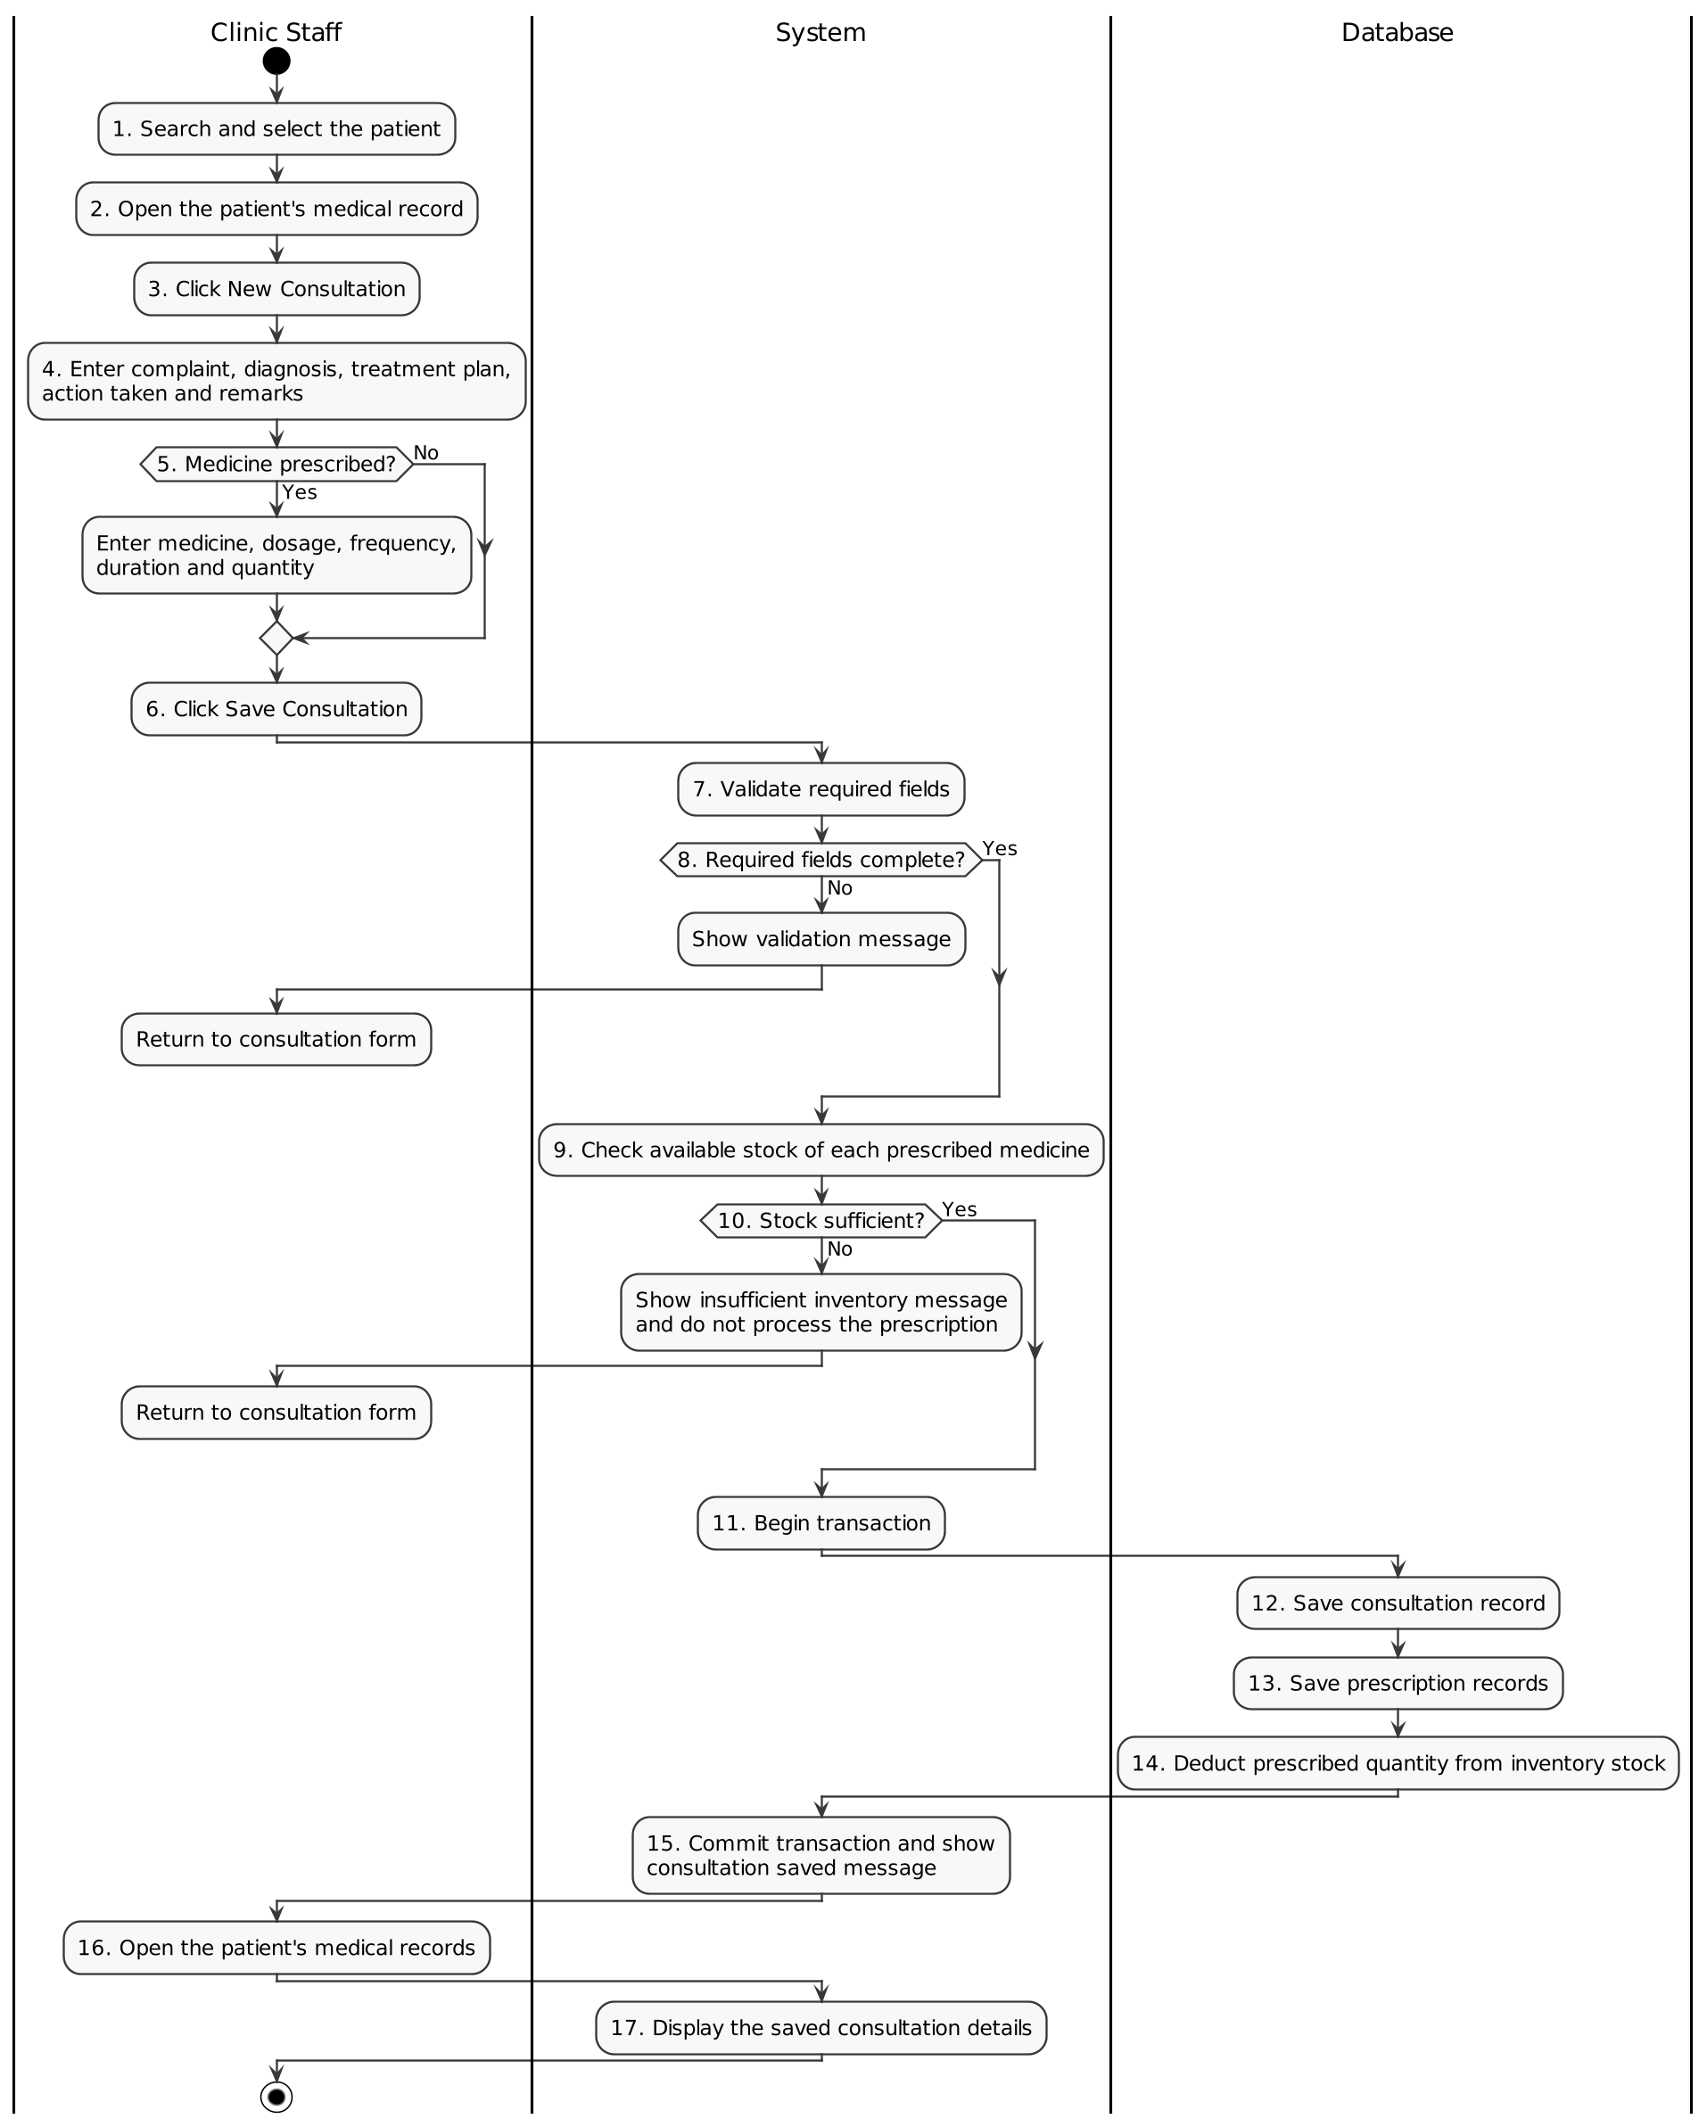

Sequence Diagram

Entity Relationship Diagram

Database Design
Table 1. Person Table (person)
Field Name | Data Type | Key | Description
person_id | INT | PK | Auto-generated unique identifier for the person.
last_name | VARCHAR(50) |  | Person's last name.
first_name | VARCHAR(50) |  | Person's first name.
middle_name | VARCHAR(50) |  | Person's middle name.
email | VARCHAR(100) |  | Unique email address of the person.
date_of_birth | DATE |  | Person's date of birth.
gender | VARCHAR(20) |  | Person's gender.
address | VARCHAR(255) |  | Person's home address.
contact_number | VARCHAR(20) |  | Person's contact number.

Table 2. Staff Table (staff)
Field Name | Data Type | Key | Description
staff_id | INT | PK | Auto-generated unique identifier for the staff record.
person_id | INT | FK | References person.person_id of this staff member.
staff_number | VARCHAR(20) |  | Unique staff identification number.
position | VARCHAR(50) |  | Staff member's job position or title.
department | VARCHAR(100) |  | Department where the staff member is assigned.

Table 3. Adviser Table (adviser)
Field Name | Data Type | Key | Description
adviser_id | INT | PK | Auto-generated unique identifier for the adviser.
person_id | INT | FK | References person.person_id of this adviser.
adviser_number | VARCHAR(20) |  | Unique identification number assigned to the adviser.

Table 4. Section Table (section)
Field Name | Data Type | Key | Description
section_id | INT | PK | Auto-generated unique identifier for the section.
section_name | VARCHAR(50) |  | Name of the class section.
adviser_id | INT | FK | References adviser.adviser_id assigned to this section.

Table 5. Student Table (student)
Field Name | Data Type | Key | Description
student_id | INT | PK | Auto-generated unique identifier for the student.
person_id | INT | FK | References person.person_id of this student.
student_number | VARCHAR(20) |  | Unique student identification number.
academic_level | VARCHAR(30) |  | Academic level (ex, Elementary, Junior High, Senior High, College).
year_level | VARCHAR(20) |  | Year or grade level of the student.
section_id | INT | FK | References section.section_id the student belongs to.

Table 6. Medical Record Table (medical_record)
Field Name | Data Type | Key | Description
medical_record_id | INT | PK | Auto-generated unique identifier for the medical record.
student_id | INT | FK | References student.student_id who owns this medical record.
medical_conditions | TEXT |  | Description of the student's known medical conditions.

Table 7. Consultation Table (consultation)
Field Name | Data Type | Key | Description
consultation_id | INT | PK | Auto-generated unique identifier for the consultation.
medical_record_id | INT | FK | References medical_record.medical_record_id of the consultation.
staff_id | INT | FK | References staff.staff_id who handled the consultation.
record_type | VARCHAR(30) |  | Type of consultation record (e.g., Check-up, Emergency).
consultation_date | DATETIME |  | Date and time the consultation took place.
complaint | TEXT |  | Patient's reported complaint or symptoms.
diagnosis | TEXT |  | Diagnosis given during the consultation.
treatment | TEXT |  | Treatment provided during the consultation.
action_taken | TEXT |  | Action or actions taken by the staff member.
remarks | TEXT |  | Additional notes or remarks about the consultation.

Table 8. Medicine Table (medicine)
Field Name | Data Type | Key | Description
medicine_id | INT | PK | Auto-generated unique identifier for the medicine.
medicine_name | VARCHAR(100) |  | Name of the medicine.
category | VARCHAR(50) |  | Category or classification of the medicine.
unit | VARCHAR(30) |  | Unit of measurement (ex, tablet, ml, bottle).

Table 9. Inventory Table (inventory)
Field Name | Data Type | Key | Description
item_id | INT | PK | Auto-generated unique identifier for the inventory item.
medicine_id | INT | FK | References medicine.medicine_id of this inventory batch.
batch_number | VARCHAR(50) |  | Batch number of the medicine stock.
stock_quantity | INT |  | Current quantity in stock. Must not be negative.
expiration_date | DATE |  | Expiration date of the medicine batch.

Table 10. Prescription Table (prescription)
Field Name | Data Type | Key | Description
prescription_id | INT | PK | Auto-generated unique identifier for the prescription.
consultation_id | INT | FK | References consultation.consultation_id of the prescription.
item_id | INT | FK | References inventory.item_id (the batch prescribed).
staff_id | INT | FK | References staff.staff_id who issued the prescription.
medication_quantity | INT |  | Quantity of medication prescribed.
dosage | VARCHAR(100) |  | Prescribed dosage amount.
frequency | VARCHAR(100) |  | How often the medication should be taken.
duration | VARCHAR(100) |  | Length of time the medication should be taken.
instructions | TEXT |  | Additional instructions for taking the medication.

